Azure
DP-900

Data Fundamentals

1

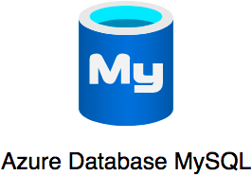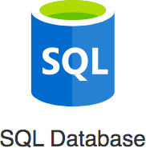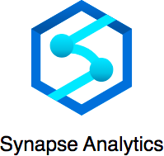

Azure has 200+ services. Exam expects you to understand 40+ services. Exam tests your decision making abilities:
Which data format will you use in which situation?
Which Azure data store will you use in which situation?
This course is designed to help you make these choices

Our Goal : Help you get certified and start your cloud journey with Azure

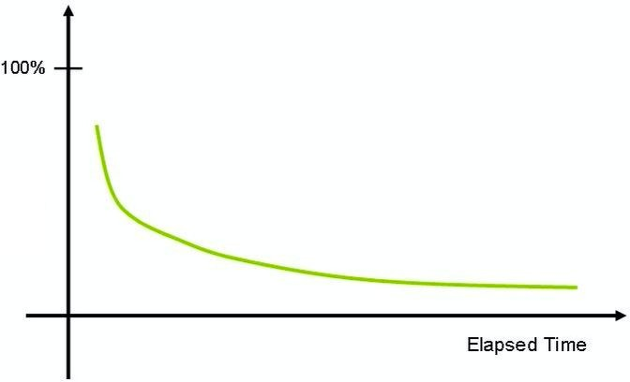
Challenging certification - Expects you to understand and REMEMBER a number of services

As time passes, humans forget things. How do you improve your chances of remembering things?
Active learning - think and take notes
Review the presentation every once in a while


Three-pronged approach to reinforce concepts:
Presentations (Video)
Demos (Video)

Two kinds of quizzes:
Text quizzes
Video quizzes

(Recommended) Take your time. Do not hesitate to replay videos!
(Recommended) Have Fun!

Getting Started - Azure

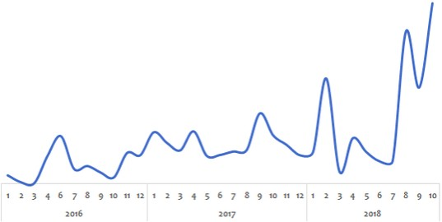

Challenge:
Peak usage during holidays and weekends
Less load during rest of the time

Solution (before the Cloud):
Procure (Buy) infrastructure for peak load
What would the infrastructure be doing during periods of low loads?



Challenge:
It suddenly becomes popular.
How to handle the sudden increase in load?

Solution (before the Cloud):
Procure (Buy) infrastructure assuming they would be successful
What if they are not successful?



High cost of procuring infrastructure
Needs ahead of time planning (Can you guess the future?) Low infrastructure utilization (PEAK LOAD provisioning)
Dedicated infrastructure maintenance team (Can a startup afford it?)


How about provisioning (renting) resources when you want them and releasing them back when you do not need them?

On-demand resource provisioning
Also called Elasticity


Trade "capital expense" for "variable expense"
Benefit from massive economies of scale
Stop guessing capacity

Stop spending money running and maintaining data centers
"Go global" in minutes

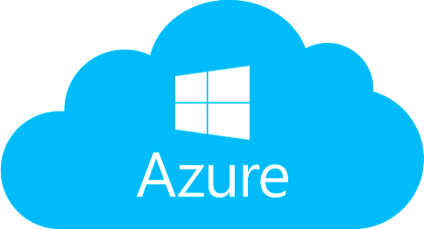
One of the leading cloud service providers Provides 200+ services
Reliable, secure and cost-effective

The entire course is all about Azure. You will learn it as we go further.

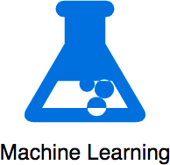

Cloud applications make use of multiple Azure services. There is no single path to learn these services independently. HOWEVER, we've worked out a simple path!

Create Azure Account

Regions and Zones

Regions and Zones
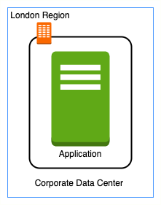

Imagine that your application is deployed in a data center in London What would be the challenges?
Challenge 1 : Slow access for users from other parts of the world (high latency)
Challenge 2 : What if the data center crashes?
Your application goes down (low availability)

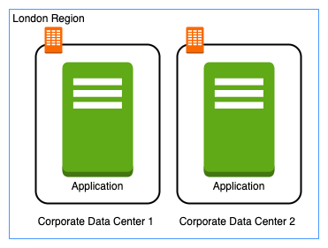

Let's add in one more data center in London What would be the challenges?
Challenge 1 : Slow access for users from other parts of the world
Challenge 2 (SOLVED) : What if one data center crashes?
Your application is still available from the other data center
Challenge 3 : What if entire region of London is unavailable?
Your application goes down

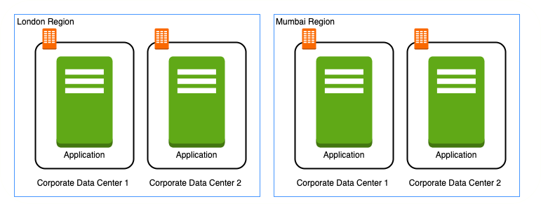

Let's add a new region : Mumbai What would be the challenges?
Challenge 1 (PARTLY SOLVED) : Slow access for users from other parts of the world
You can solve this by adding deployments for your applications in other regions
Challenge 2 (SOLVED) : What if one data center crashes?
Your application is still live from the other data centers
Challenge 3 (SOLVED) : What if entire region of London is unavailable?
Your application is served from Mumbai

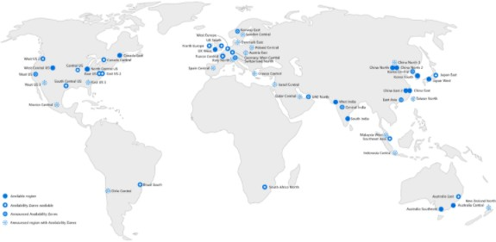
Imagine setting up data centers in different regions around the world

Would that be easy?
(Solution) Azure provides 60+ regions

around the world
Expanding every year
Region : Specific geographical location to host your resources
Advantages:
High Availability
Low Latency
Global Footprint
Adhere to government regulations

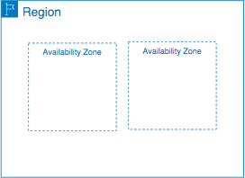
How to achieve high availability in the same region (or geographic location)?
Enter Availability Zones
Multiple AZs (3) in a region
One or more discrete data centers
Each AZ has independent & redundant power, networking & connectivity
AZs in a region are connected through low-latency links
(Advantage) Increased availability and fault tolerance within same region
Survive the failure of a complete data center

(Remember) NOT all Azure regions have Availability Zones

New Regions and AZs are constantly added

Region | Availability Zones
(US) East US | 3
(Europe) West Europe | 3
(Asia Pacific) Southeast Asia | 3
(South America) Brazil South | 3
(US) West Central US | 0

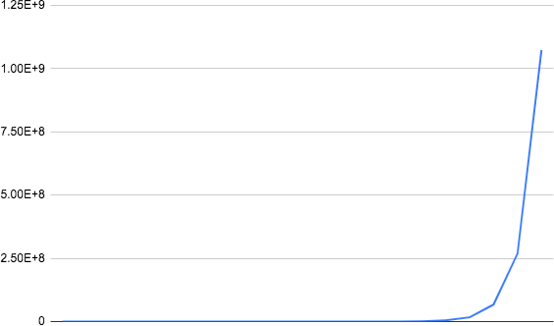
Data is the "oil of the 21st Century Digital Economy"
Amount of data generated increasing exponentially
Mobile devices, IOT devices, application metrics etc

Variety of
Data formats: Structured, Semi Structured and Unstructured
Data store options: Relational databases, NoSQL databases, Analytical databases, Object/Block/File storage ...

Store data efficiently and gain intelligence
Goal of the course: Help you choose specific data format and Azure data store for your use case
We will start with 10,000 feet overview of cloud:
Regions, Zones and IaaS/PaaS/SaaS
After that, play with different data formats and data storage options in Azure

IaaS vs PaaS vs SaaS

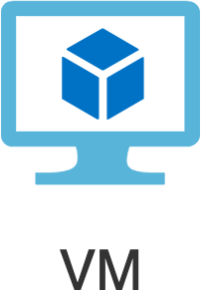
In corporate data centers, data stores are deployed on physical servers
Where do you deploy data stores in the cloud?
Rent virtual servers
Virtual Machines - Virtual servers in Azure
Azure Virtual Machines - Provision & Manage Virtual Machines

You need to take care of:

OS installation & upgrades
Database installation & upgrades Availability (create a standby database) Durability (take regular backups) Scaling compute & storage


Do you want to continue running databases in the cloud, the
same way you run them in your data center?
OR are there OTHER approaches?
Let's understand some terminology used with cloud services:
IaaS (Infrastructure as a Service)
PaaS (Platform as a Service)
SaaS (Software as a Service)

Let's get on a quick journey to understand these!

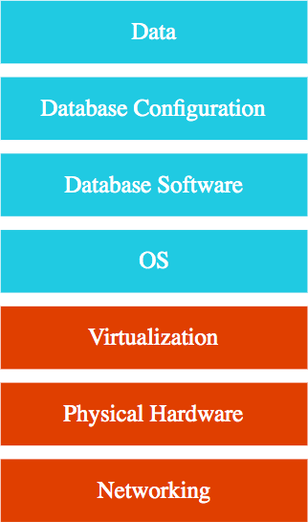
Use only infrastructure from cloud provider Example: Running SQL Server on a VM Cloud Provider is responsible for:
Virtualization, Hardware and Networking

You are responsible for:
OS upgrades and patches
Database software and upgrades
Database Configuration (Tables, Indexes, Views etc) Data
Scaling of compute & storage, Availability and Durability

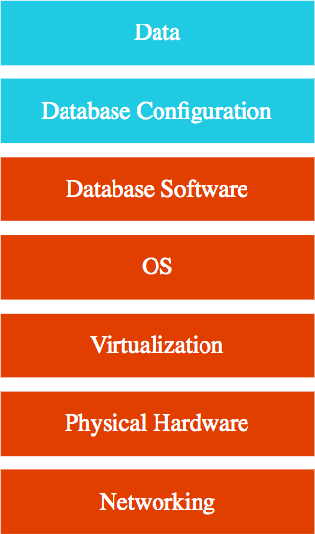
Use a platform provided by cloud
Cloud provider is responsible for:
Virtualization, Hardware and Networking
OS upgrades and patches Database software and upgrades Scaling, Availability, Durability etc..

You are responsible for:
Database Configuration (Tables, Views, Indexes, ...)
Data

Examples: Azure SQL Database, Azure Cosmos DB and a lot more ...
You will NOT have access to OS and Database software (most of the times!)


Centrally hosted sohware (mostly on the cloud)
Offered on a subscription basis (pay-as-you-go)
Examples:
Email, calendaring & office tools (such as Outlook 365, Microsoft Office 365, Gmail, Google Docs)
Customer relationship management (CRM), enterprise resource planning (ERP) and document management tools
Cloud provider is responsible for:
OS (incl. upgrades and patches)
Application Runtime
Auto scaling, Availability & Load balancing etc.. Application code and/or
Application Configuration (How much memory? How many instances? ..)
Customer is responsible for:
Configuring the software!

Scenario Solution

IaaS or PaaS or SaaS: Deploy a Database in Virtual Machines IaaS

IaaS or PaaS or SaaS: Using Gmail SaaS

IaaS or PaaS or SaaS: Using Azure SQL Database to create a database PaaS True or False: Customer is responsible for OS updates when using PaaS False True or False: Customer is responsible for Availability when using PaaS False True or False: In PaaS, customer has access to VM instances False True or False: In PaaS, customer can customize OS and install custom sohware False True or False: In PaaS, customer can configure hardware needs (memory, cpu etc) True

Data Formats & Data Stores

10,000 Feet Overview


Data is the "oil of the 21st Century Digital Economy" Amount of data generated increasing exponentially Data formats:
Structured: Tables, Rows and Columns (Relational)
Semi Structured: Key-Value, Document (JSON), Graph, etc Unstructured: Video, Audio, Image, Text files, Binary files ...

Data stores:
Relational databases
NoSQL databases Analytical databases Object/Block/File storage

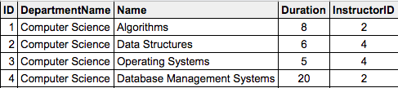
Data stored in Tables - Rows & Columns
Predefined schema - Tables, Relationships and Constraints
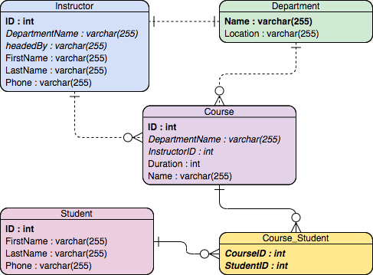
Define indexes - Query efficiently on all columns

Used for
OLTP (Online Transaction Processing) use cases and
OLAP (Online Analytics Processing) use cases


Applications where large number of users make large number (millions) of transactions
Transaction - small, discrete, unit of work
Example: Transfer money from your account to your friend's account
Heavy writes and moderate reads Quick processing expected

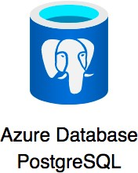
Use cases: Most traditional applications - banking, e- commerce, ..
Popular databases: MySQL, Oracle, SQL Server etc Some Azure Managed Services:
Azure SQL Database: Managed Microsoft SQL Server
Azure Database for MySQL: Managed MySQL
Azure Database for PostgreSQL: Managed PostgreSQL


Applications allowing users to analyze petabytes of data
Examples: Reporting applications, Data warehouses, Business intelligence applications, Analytics systems
Data is consolidated from multiple (typically transactional) databases
Sample application : Decide insurance premiums analyzing data from last hundred years
Azure Managed Service: Azure Synapse Analytics
Petabyte-scale distributed data ware house
Unified experience for developing end-to-end analytics solutions
Data integration + Data warehouse + Data analytics
Run complex queries across petabytes of data Earlier called Azure SQL Data Warehouse

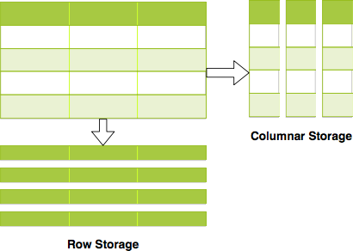
OLAP and OLTP use similar data structures

BUT very different approach in how data is stored
OLTP databases use row storage
Each table row is stored together
Efficient for processing small transactions
OLAP databases use columnar storage
Each table column is stored together
High compression - store petabytes of data efficiently
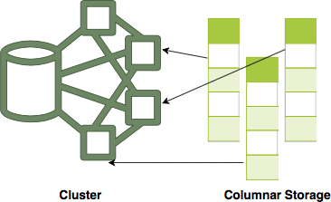
Distribute data - one table in multiple cluster nodes
Execute single query across multiple nodes - Complex queries can be executed efficiently

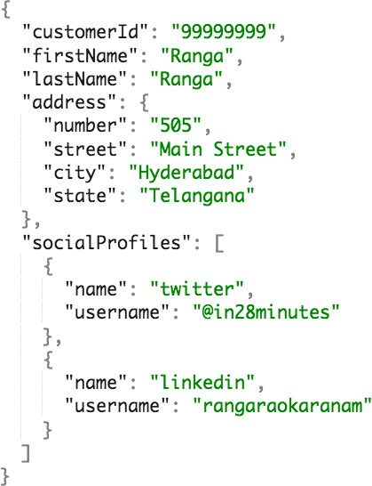
Data has some structure BUT not very strict

Semi Structured Data is stored in NoSQL databases
NoSQL = not only SQL
Flexible schema
Structure data the way your application needs it
Let the structure evolve with time
Horizontally scale to petabytes of data with millions of TPS
Managed Service: Azure Cosmos DB

Types of Semi Structured Data:
Document
Key Value Graph
Column Family


Data stored as collection of documents
Typically JSON (Javascript Object Notation)
Be careful with formatting (name/value pairs, commas etc)
address - Child Object - {}
socialProfiles - Array - []
Documents are retrieved by unique id (called the key)
Typically, you can define additional indexes
Documents don't need to have the same structure
No strict schema defined on database
Apps should handle variations (application defined schema)
Typically, information in one document would be stored in multiple tables, if you were using a relational database
Use cases: Product Catalog, Profile, Shopping Cart etc Managed Service: Azure Cosmos DB SQL API & MongoDB API

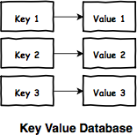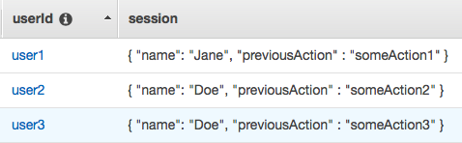

Similar to a HashMap
Key - Unique identifier to retrieve a specific value
Value - Number or a String or a complex object, like a JSON file Supports simple lookups - query by keys
NOT optimized for query by values
Typically, no other indexes allowed
Use cases: Session Store, Caching Data
Managed Services: Azure Cosmos DB Table API, Azure Table Storage



Social media applications have data with complex relationships How do you store such data?
As a graph in Graph Databases
Used to store data with complex relationships

Contains nodes and edges (relationships)
Use cases: People and relationships, Organizational charts, Fraud Detection
Managed Service: Azure Cosmos DB Gremlin API

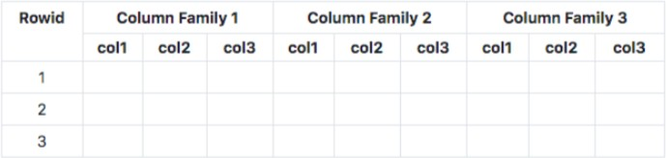

Data organized into rows and columns

Can appear similar to a relational database
IMPORTANT FEATURE: Columns are divided into groups called column-family
Rows can be sparse (does NOT need to have value for every column)

Use cases: IOT streams and real time analytics, financial data - transaction histories, stock prices etc
Managed Service: Azure Cosmos DB Cassandra API

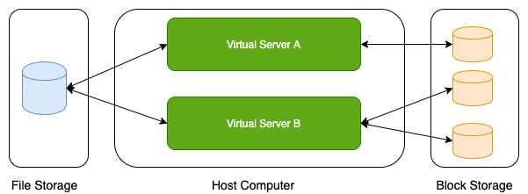

Data which does not have any structure (Audio files, Video files, Binary files)
What is the type of storage of your hard disk?
Block Storage (Azure Managed Service: Azure Disks)
You've created a file share to share a set of files with your colleagues in a enterprise. What type of storage are you using?
File Storage (Azure Managed Service: Azure Files)
You want to be able to upload/download objects using a REST API without mounting them onto your VM. What type of storage are you using?
Object Storage (Azure Managed Service: Azure Blob Storage)


Relational Data (Structured Data)
OLTP: SQL Server on Azure VMs, Azure SQL Database (or Azure SQL Managed Instance), Azure Database for PostgreSQL, MariaDB, MySQL
OLAP: Azure Synapse Analytics

Non Relational Data (Semi Structured/Unstructured Data)
Semi Structured - Document (JSON)
Azure Cosmos DB SQL API and Cosmos DB MongoDB API
Semi Structured - Key-Value

Azure Cosmos DB Table API, Azure Table Storage
Semi Structured - Column-Family
Azure Cosmos DB Cassandra API
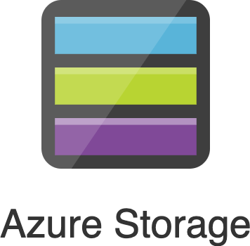
Semi Structured - Graph
Azure Cosmos DB Gremlin API
Unstructured Data
Block Storage (Azure Disks), File Storage (Azure Files), Object Storage (Azure Blob Storage)

Scenario Solution

A start up with quickly evolving schema for storing documents
Transactional local database processing thousands of transactions per second
Store complex relationships between transactions to identify fraud
Database for analytics processing of petabytes of structured data
Azure Cosmos DB SQL API and Cosmos DB MongoDB API
Azure SQL Database and other relational databases..
Azure Cosmos DB Gremlin API Azure Synapse Analytics

File share between multiple VMs Azure Files

Storing profile images uploaded by your users Azure Blob Storage

Relational Databases


Structured Data - Tables, Rows and Columns

Structured Query Language (SQL) for retrieving and managing data Recommended when strong transactional consistency guarantees are needed


Database schema is mandatory Azure Managed Services:
Azure SQL Database
Azure SQL Managed Instance Azure Database for PostgreSQL Azure Database for MySQL Azure Database for MariaDB


Fully Managed Service for Microsoft SQL Server 99.99% availability

Built-in high availability, automatic updates and backups Flexible and responsive serverless compute
Hyperscale (up to 100 TB) storage
Transparent data encryption(TDE) - Data is automatically encrypted at rest

Authentication: SQL Server authentication or Active Directory (and MFA)


Relational Databases are modeled using Tables and Relationships
A Course has an Instructor
A Course belongs to a Department

Table: Table contains columns and rows
All rows in a table have same set of columns
Relationship between tables is established using Primary Key and Foreign Key
Primary Key: Uniquely identifies a row in a table
Foreign Key: Provides a link between data in two tables


SQL: Language used to perform operations on relational databases
Data Definition Language (DDL): Create and modify structure of database objects
Create: Create a database or its constituent objects (Table, View, Index etc)
Drop: Delete objects (Table, View, Index) from database Alter: Alter structure of the database
Data Query Language (DQL): Perform queries on the data
Example: SELECT * from Course, SELECT Count(*) from Course
Data Manipulation Language (DML): Insert, update or delete data
Example: insert into Course values (1, 'AZ-900', 1);
Example: Update Course Set title='AZ-900 Azure Fundamentals' where id=1
Example: Delete from Course where id=1
Data Control Language (DCL): Manage permissions and other controls
Example: Grant and revoke user access - GRANT SELECT ON course TO user1
Transaction Control Language(TCL): Control transactions within a database
Commit - commits a transaction
Rollback - rollbacks a transaction (used in case of an error)

CREATE CLUSTERED INDEX INDEX_NAME on TABLE (COLUMN_NAME);
CREATE NONCLUSTERED INDEX INDEX_NAME on TABLE (COLUMN_NAME);
Allows efficient data retrieval from a database
Combination of one or more columns

Remember: An index is automatically created with the primary key
Remember: A table can have more than one index
Two Types of Indexes:
Clustered: Data in table is stored in the order of the index key values
Remember: Only one clustered index per table ( Why? - data rows can only be sorted in one way)
Non-clustered indexes: Index stored separately with pointers to the data rows

create view all_courses_with_students as
select course_id, student_id, first_name, last_name, title from Course_Student, Student, Course
where Course_Student.student_id = Student.id and Course_Student.course_id=Course.id;

View: Virtual table mapped to a query
Can be used just like a table in SQL queries

Use cases: Add calculated columns, join multiple tables, filter unnecessary columns

Goals in designing relational databases:
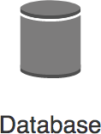
High Data Integrity
Minimum Data Redundancy (or Duplication)

How do achieve these goals?
Database Normalization: "Process of restructuring a relational database to reduce data redundancy and improve data integrity"
First Normal Form (1NF): Single(atomic) valued columns
Violation Example: A column named address
Second Normal Form (2NF): Eliminate redundant data
Third Normal Form (3NF): Move columns not directly dependent on primary key
(REMEMBER) There are other normal forms (4NF, 5NF, ...) but 3NF is considered good enough for most relational data
Advantages of Normalization
Avoid same data being duplicated in multiple tables
Reduce disk space wastage Avoid data inconsistencies

Unnormalized - Enrollment Details
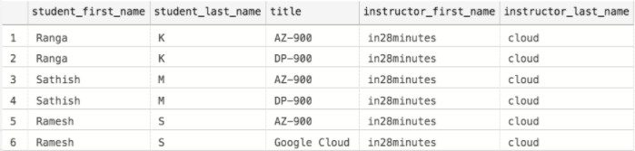
Normalized - Student

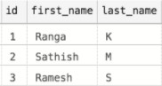

Normalized - Instructor
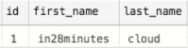

Normalized - Course

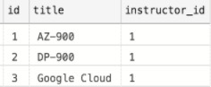

Normalized - Course_Student
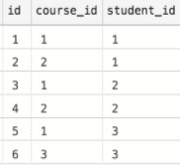

Transaction: Sequence of operations that need to be atomic

All operations are successful (commit) OR NONE are successful (rollback)
Example: Transfer $10 from Account A to B
Operation 1: Reduce $10 from Account A
Operation 2: Add $10 to Account B
If Operation 1 is successful and Operation 2 fails - Inconsistent state
You don't want that!

Properties: ACID (Atomicity, Consistency, Isolation, Durability)
Atomicity: Each transaction is atomic (either succeeds completely, or fails completely)
Consistency: Database must be consistent before and after the transaction
Isolation: Multiple Transactions occur independently
Durability: Once a transaction is committed, it remains committed even if there are system failures (a power outage, for example)

Remember: Supported in all Relational Databases


vCore-based: Choose between provisioned or serverless compute
OPTIONAL: Hyperscale (Autoscale storage)
Higher compute, memory, I/O, and storage limits Supports BYOL
Serverless Compute: Database is paused during inactive periods
You are only billed for storage during inactive periods
If there is any activity, database is automatically resumed

DTU-based: Bundled compute and storage packages
Balanced allocation of CPU, memory and IO
Assign DTUs (relative - Double DTU => Double resources) Recommended when you want to keep things simple
You CANNOT scale CPU, memory and IO independently
Use DTUs for small and medium databases (< few hundred DTUs)

Feature Description

Single database Great fit for modern, cloud-born applications
Fully managed database with predictable performance Hyperscale storage (up to 100TB)
Serverless compute

Elastic pool Cost-effective solution for multiple databases with variable usage patterns Manage multiple databases within a fixed budget

Database server Database servers are used to manage groups of single databases and elastic pools.
Things configured at Database server level: Access management, Backup management

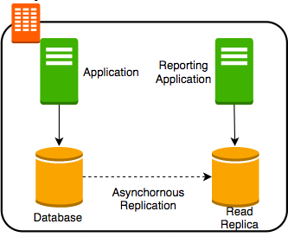
Prerequisites to connect and query from Azure SQL database:
1: Connection Security: Database should allow connection from
your IP address
2: User should be created in the database
3: User should have grants (permissions) to perform queries - Select, Insert etc.

Use BYOL to reduce license costs
Use read-only replicas (Read scale-out) for offloading read-only query workloads

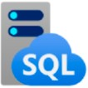
Another Fully Managed Service for Microsoft SQL Server What's New: Near 100% SQL Server feature compatibility

Recommended when migrating on premise SQL Servers to Azure
Azure SQL managed instance features NOT in Azure SQL Database
Cross-database queries (and transactions) within a single SQL Server instance
Database Mail
Built in SQL Server Agent
Service to execute scheduled administrative tasks - jobs in SQL Server
Native virtual network support
Supports only vCore-based purchasing model

(Remember) SQL Server Analysis Services (SSAS), SQL Server Reporting Services (SSRS), Polybase: NOT supported by both Azure SQL Database and SQL Managed Instance

Service Description

SQL Server on Azure Virtual Machines
Provides full administrative control over the SQL Server instance and underlying OS for migration to Azure

Azure SQL Database Fully Managed Service for Microsoft SQL Server.
Recommended for cloud-born applications

Azure SQL managed instance
Full (Near 100%) SQL Server access and feature compatibility Recommended for migrating on-premise SQL Server databases
Azure SQL managed instance ONLY features: Cross-database queries, Database Mail Support, SQL Server Agent etc.


Fully managed, scalable MySQL database

Supports 5.6, 5.7 and 8.0 community editions of MySQL
99.99% availability
Choose single zone or zone redundant high availability

Automatic updates and backups
Alternative: Azure Database for MariaDB
MariaDB: community-developed, commercially supported fork of MySQL


Fully managed, intelligent and scalable PostgreSQL
99.99% availability
Choose single zone or zone redundant high availability
Automatic updates and backups

Single Server and Hyperscale Options
Hyperscale: Scale to hundreds of nodes and execute queries across multiple nodes

Scenario Solution

You are migrating a Microsoh SQL Server database to cloud. You want full access to OS and Microsoh SQL Server installation.
You are migrating a Microsoh SQL Server database to cloud. You do NOT need full access to OS and Microsoh SQL Server installation. However, you need access to Database Mail and SQL Server Agent.
SQL Server on VM

Azure SQL Managed Instance

You want create a new managed Microsoh SQL Server database in cloud Azure SQL
Database, Azure SQL Managed Instance

Which category of SQL is this? GRANT SELECT ON course TO user1 Data Control
Language (DCL)

Scenario Solution

Which category of SQL is this? create table course (...)
Your queries on a relational databases are slow. What is the first thing that you would consider doing?
Your colleague asked you to normalize your tables. What should be your goals?
How can you offload read-only workloads from Azure SQL database?
Data Definition Language (DDL) Check if there is an index
High Data Integrity & Minimum Data Redundancy (or Duplication)
Read-only replicas (Read scale-out)

Azure Cosmos DB


Relational Data (Structured Data)
OLTP: Azure SQL Database, Azure SQL Managed Instance, SQL Server on Azure VMs, Azure Database for PostgreSQL, MariaDB, MySQL
OLAP: Azure Synapse Analytics

Non Relational Data (Semi Structured/Unstructured Data)
Semi Structured - Document (JSON)
Azure Cosmos DB SQL API and Cosmos DB MongoDB API
Semi Structured - Key-Value

Azure Cosmos DB Table API, Azure Table Storage
Semi Structured - Column-Family
Azure Cosmos DB Cassandra API

Semi Structured - Graph
Azure Cosmos DB Gremlin API
Unstructured Data
Block Storage (Azure Disks), File Storage (Azure Files), Object Storage (Azure Blob Storage)


Fully managed NoSQL database service

Global database: Automatically replicates data across multiple Azure regions
Single-digit millisecond response times
99.999% availability
Automatic scaling (serverless) - Storage and Compute Multi-region writes
Data distribution to any Azure region with the click of a button
Your app doesn't need to be paused or redeployed to add or remove a region

Structure: Azure Cosmos account(s) > database(s) > container(s) > item(s)


Core(SQL): SQL based API for working with documents
MongoDB: Document with MongoDB API
Move existing MongoDB workloads
Table: Key Value
Ideal for moving existing Azure Table storage workloads
Gremlin: Graph
Store complex relationships between data
Cassandra: Column Family

REMEMBER: You need a separate Cosmos DB account for each type of API

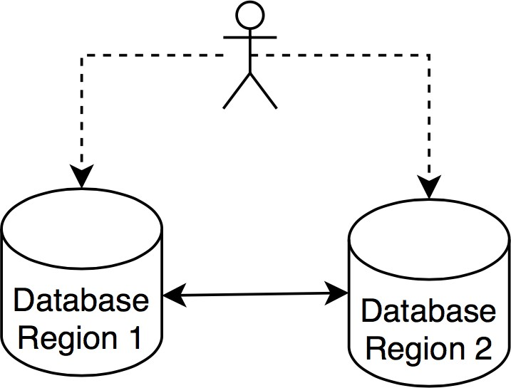
Single-digit millisecond response times even if you scale to petabytes of data with millions of TPS
Horizontal scalability
One thing I love about Azure Cosmos DB: Flexibility
Structure data the way your application needs it
Let the structure evolve with time
Provides a variety of consistency levels
Strong, Bounded staleness, Session, Consistent prefix, Eventual
If you are familiar with SQL but want to still use document database use SQL API
Options for key-value, column-family and graph databases

Entity | SQL | Cassandra | MongoDB | Gremlin | Table
Database | Database | Keyspace | Database | Database | NA
Container | Container | Table | Collection | Graph | Table
Item | Item | Row | Document | Node or edge | Item

Each container is horizontally partitioned in an Azure region
ALSO distributed to all Azure
regions associated with the Cosmos DB account
Items in a container divided into logical partitions based on the partition key

Cosmos DB take care of categorizing logical partitions into physical partitions
Ensures high availability and durability

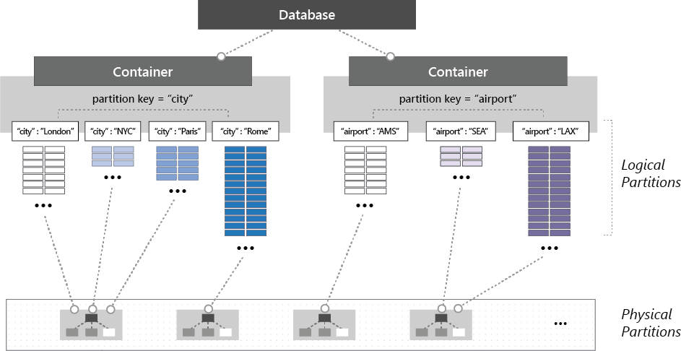
(https://docs.microsok.com)

Factor Provisioned throughput Serverless

Description Provision throughput in Request Units per
second
No need to provision capacity. Auto scales to meet request load.

What are you billed for?
RUs provisioned per hour (usage does NOT matter) + Storage
per-hour RUs consumed + Storage

When to use? Continuous predictable traffic Intermittent, unpredictable traffic

Multi Regions Yes No - only in 1 Azure region

Max storage per container
No limit 50 GB

Performance < 10 ms latency for point-reads and writes < 10 ms latency for point-reads and < 30 ms
for writes

Scenario Solution

How can you increase storage associated with Azure Cosmos DB?
What is the high level structure of storing data in Azure Cosmos DB?
How are items in a container divided into logical partitions?
You want to store data for a social networking app with complex relationships
Automatic scaling (serverless)

Azure Cosmos account(s) > database(s) > container(s) > item(s)
Using partition key Gremlin API

You want SQL based API for working with documents Core(SQL) API

You want to move existing MongoDB workloads to Azure MongoDB API

Azure Storage


Relational Data (Structured Data)
OLTP: Azure SQL Database, Azure SQL Managed Instance, SQL Server on Azure VMs, Azure Database for PostgreSQL, MariaDB, MySQL
OLAP: Azure Synapse Analytics

Non Relational Data (Semi Structured/Unstructured Data)
Semi Structured - Document (JSON)
Azure Cosmos DB SQL API and Cosmos DB MongoDB API
Semi Structured - Key-Value

Azure Cosmos DB Table API, Azure Table Storage
Semi Structured - Column-Family
Azure Cosmos DB Cassandra API

Semi Structured - Graph
Azure Cosmos DB Gremlin API
Unstructured Data
Block Storage (Azure Disks), File Storage (Azure Files), Object Storage (Azure Blob Storage)

Managed Cloud Storage Solution

Highly available, durable and massively scalable (upto few PetaBytes)

Core Storage Services:
Azure Disks: Block storage (hard disks) for Azure VMs
Azure Files: File shares for cloud and on-premises Azure Blobs: Object store for text and binary data Azure Queues: Decouple applications using messaging Azure Tables: NoSQL store (Very Basic)
Prefer Azure Cosmos DB for NoSQL

(PRE-REQUISITE) Storage Account is needed for Azure Files, Azure Blobs, Azure Queues and Azure Tables

Option Redundancy Discussion

Locally redundant storage (LRS)
Zone-redundant storage (ZRS)
Geo-redundant storage (GRS)
Three synchronous copies in same data center Least expensive and least
availability
Three synchronous copies in three AZs in the primary region
LRS + Asynchronous copy to secondary region (three more copies using LRS)

Geo-zone-redundant storage (GZRS)
ZRS + Asynchronous copy to secondary region (three more copies using LRS)
Most expensive and highest availability

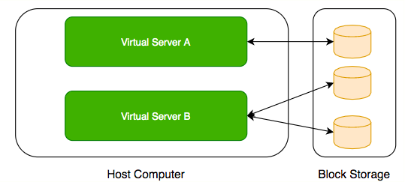
Use case: Hard-disks attached to your computers
Typically, ONE Block Storage device can be connected to ONE virtual server

HOWEVER, you can connect multiple different block storage devices to one virtual server

Disk storage: Disks for Azure VMs


Types:
Standard HDD: Recommended for Backup, non-critical, infrequent access
Standard SSD: Recommended for Web servers, lightly used enterprise applications and dev/test environments
Premium SSD disks: Recommended for production and performance sensitive workloads
Ultra disks (SSD): Recommended for IO-intensive workloads such as SAP HANA, top tier databases (for example, SQL, Oracle), and other transaction-heavy workloads
Premium and Ultra provide very high availability
Managed vs Unmanaged Disks:
Managed Disks are easy to use:
Azure handles storage
High fault tolerance and availability
Unmanaged Disks are old and tricky (Avoid them if you can)
You need to manage storage and storage account
Disks stored in Containers (NOT Docker containers. Completely unrelated.)

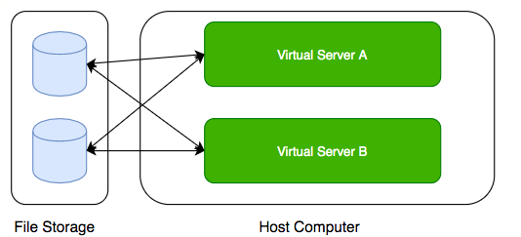
Media workflows need huge shared storage for things like video editing
Enterprise users need a quick way to share files in a secure & organized way Azure Files:
Managed File Shares
Connect from multiple devices concurrently:
From cloud or on-premises
From different OS: Windows, Linux, and macOS
Supports Server Message Block (SMB) and Network File System (NFS) protocols
Usecase: Shared files between multiple VMs (example: configuration files)


Azure Blob Storage: Object storage in Azure

Structure: Storage Account > Container(s) > Blob(s) Store massive volumes of unstructured data
Store all file types - text, binary, backup & archives:
Media files and archives, Application packages and logs
Backups of your databases or storage devices

Three Types of Blobs
Block Blobs: Store text or binary files (videos, archives etc)
Append Blobs: Store log files (Ideal for append operations)
Page Blobs: Foundation for Azure IaaS Disks (512-byte pages up to 8 TB)
Azure Data Lake Storage Gen2: Azure Blob Storage Enhanced
Designed for enterprise big data analytics (exabytes, hierarchical)
Low-cost, tiered storage, with high availability/disaster recovery

Different kinds of data can be stored in Blob Storage

Media files, website static content
Backups of your databases or storage devices Long term archives
Huge variations in access patterns

Can I pay a cheaper price for objects I access less frequently?

Access tiers
Hot: Store frequently accessed data
Cool: Infrequently accessed data stored for min. 30 days
Archive: Rarely accessed data stored for min. 180 days
Lowest storage cost BUT Highest access cost
Access latency: In hours
To access: Rehydrate (Change access tier to hot or cool) OR
Copy to another blob with access tier hot or cool
You can change access tiers of an object at any point in time


Azure Queues: Decouple applications using messaging
Azure Tables: NoSQL store (Very Basic)
A key/value store
Store and retrieve values by key
Supports simple query, insert, and delete operations
Cosmos DB Table API is recommended as key/value store for newer usecases (supports multi-master in multiple regions)
Azure Tables only supports read replicas in other regions
GRS or GZRS: Data in secondary region is generally NOT available for read or write access
Available for read or write only in case of failover to the secondary region
To enable round the clock read access:
Use read-access geo-redundant storage (RA-GRS) or read-access geo-zone-redundant storage (RA-GZRS)

Scenario Solution

What is needed before storing data to Azure Files, Azure Blobs, Azure Queues and Azure Tables?
You have a Storage Account and you are making use of Azure Blob Storage. You want to create a new file share. Is it mandatory to create a new Storage Account?
Storage Account No

You want highest availability for data in your Storage Account Geo-zone- redundant
storage (GZRS)

Which service supports Server Message Block (SMB) and Network File System (NFS) protocols?
You are not planning to access your data in Azure Blob storage for a few years. You can wait for a few hours when you need to access the data. How can you reduce your costs?
Azure Files

Move data to Archive tier

Data Analytics

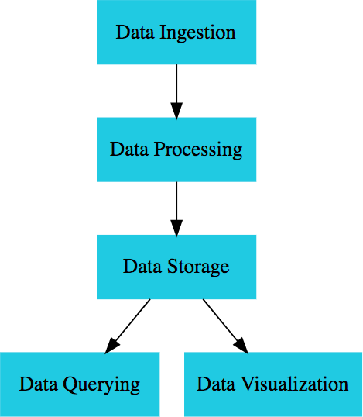
Goal: Convert raw data to intelligence
Uncover trends and discover meaningful information
Find new opportunities and identify weaknesses Increase efficiency and improve customer satisfaction Make appropriate business decisions

Raw data can be from different sources:
Customer purchases, bank transactions, stock prices, weather data, monitoring devices etc

Approach: Ingest => Process => Store (data warehouse or a data lake) => Analyze
Ex: Decide future sales using past customer behavior Ex: Faster diagnosis & treatment using patient history


Data Ingestion: Capture raw data
From various sources (stream or batch)
Example: Weather data, sales records, user actions - websites ..
Data Processing: Process data
Raw data is not suitable for querying
Clean (remove duplicates), filter (remove anomalies) and/or aggregate data
Transform data to required format (Transformation)
Data Storage: Store to data warehouse or data lake
Data Querying: Run queries to analyze data

Data Visualization: Create visualizations to make it easier to understand data and make better decisions
Create dashboards, charts and reports (capture trends)
Help business spot trends, outliers, and hidden patterns in data


Descriptive analytics: What’s happening?
Based on historical/current data
Monitor status (of KPIs) and generate alerts Example: Generating reports (current vs planned)
Diagnostic analytics: Why is something happening?
Take findings from descriptive analytics and dig deeper
Example: Why did sales increase last month? Example: Why are sales low in Netherlands?
Predictive analytics: What will happen?
Predict probability based on historical data
Mitigate risk and identify opportunities Example: What will be the future demand?
Example: Calculate probability of something happening in future


Prescriptive analytics: What actions should we take?
Use insights from predictive analytics and make data-driven informed decisions
Still in early stages
Example: What can I do to increase probability of this course being successful in future?
Cognitive analytics: Make analytic tools to think like humans
Combine traditional analytics techniques with AI and ML
features
Examples: Speech to text (transcription or subtitles), text to speech, Video Analysis, Image Analysis, Semantic Analysis of Text (Analyze reviews)

3Vs of Big Data
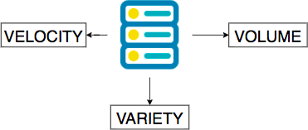
Volume: Terabytes to Petabytes to Exabytes
Variety: Structured, Semi structured, Unstructured

Velocity: Batch, Streaming ..
Terminology: Data warehouse vs Data lake
Data warehouse: PBs of Storage + Compute (Typically)
Data stored in a format ready for specific analysis! (processed data)
Examples: Teradata, BigQuery(GCP), Redshift(AWS), Azure Synapse Analytics
Typically uses specialized hardware
Data lake: Typically retains all raw data (compressed)
Typically object storage is used as data lake
Amazon S3, Google Cloud Storage, Azure Data Lake Storage Gen2 etc..
Flexibility while saving cost
Perform ad-hoc analysis on demand
Analytics & intelligence services (even data warehouses) can directly read from data lake
Azure Synapse Analytics, BigQuery(GCP) etc..

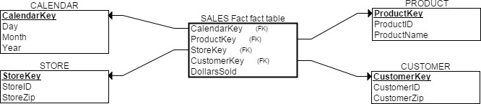

How do you structure data for quick analysis in a data warehouse?
Option: Star Schema
Modeling approach most widely used by relational data warehouses
Each Table classified as "Dimension" or "Fact":
Fact tables: Quantitative data - Data generated in a transactional system (typically)
Contains observations or events (sales orders, stock balances, temperatures ...)
Dimension tables: Contain descriptive attributes related to fact data
Example: Product, Customer, Store, Calendar

Advantage: Star schemas are de-normalized and are easier to query

Azure Synapse Analytics: End-to-end analytics solutions
Data integration + Enterprise data warehouse + Data analytics
Create SQL and Spark pools to analyze data
Azure Data Factory: Fully managed serverless service to build complex data pipelines
Extract-transform-load (ETL), extract-load-transform (ELT) and data integration

Power BI: Create visualization around data
Unify data and create BI reports & dashboards


Hadoop based approaches:
Apache Hadoop: Create datasets with variety of data. Get intelligence.
Runs on commodity servers with attached storage (Large clusters - thousands of nodes)
Hadoop Distributed File System (HDFS): Primary data storage

MapReduce: Write Java, Python, .. apps to process data
Enables massive parallelization
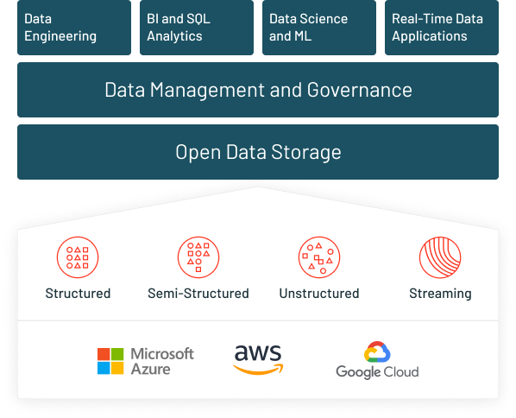
HIVE: Query using SQL
Apache Spark: How about processing in-memory?
Really fast: Can be up to 100 times faster than MapReduce (if you make sufficient memory available)
Supports Java, Python, R, SQL and Scala programming languages Run data analytics, data processing and machine learning workloads
Has become very popular and is offered as a separate service in most cloud platforms!
Databricks: Web-based platform for working with Spark
Centralized platform for machine learning, streaming analytics and business intelligence workloads
Founded by the creators of Apache Spark
Automated cluster management


Azure HDInsight: Managed Apache Hadoop Azure service
Process big data with Hadoop, Spark
Azure Databricks: Managed Apache Spark service

Premium Spark offering
Focused only on running Apache Spark workloads
Can consume data from Azure SQL Database, Event hubs, Cosmos DB

Other Azure Spark Integrations:
Azure Synapse Analytics: Can run Spark jobs using "Apache Spark for Azure Synapse"
Azure Data Factory: Run pipelines involving Azure services like Azure HDInsight, Azure Databricks

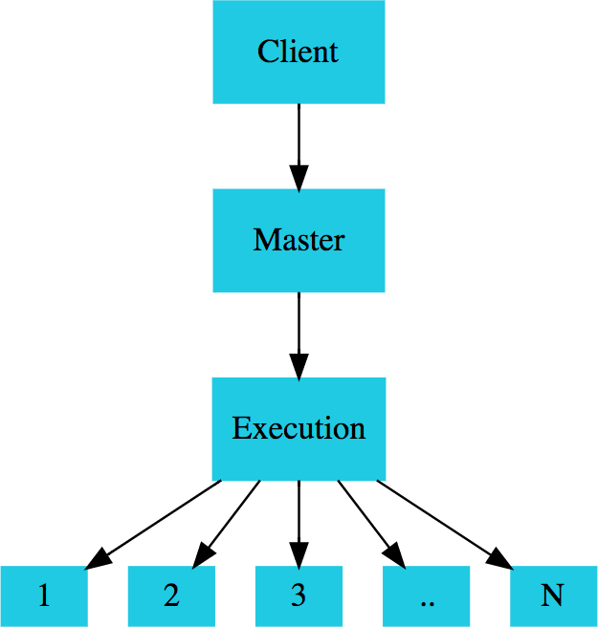
Split processing across multiple compute nodes Typically separate storage and compute
Use Data lake as storage (for example)
Scale compute on demand

Examples: Spark, Azure Synapse Analytics
Some services run Spark in serverless mode!

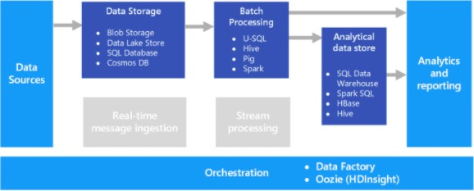

(https://docs.microsok.com)
Batch Processing: Buffering and processing data in groups
Define condition - how often to run? (every 6 hours or after 10K records)
Advantages: Process huge volumes of data during off-peak hours (overnight, for example)
Typically takes longer to run (minutes to hours to days)
Example: Read from storage (Azure Data Lake Store), process, and write to Relational Database or NoSQL Database or Data warehouse

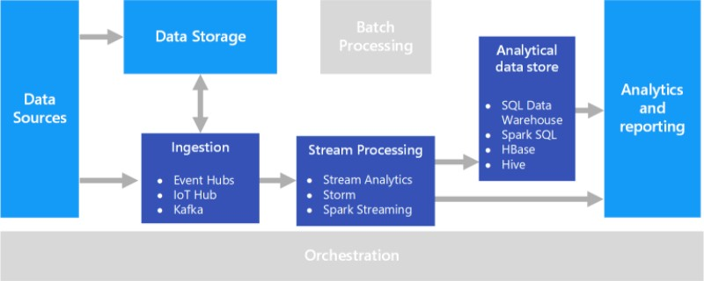

(https://docs.microsok.com)
Streaming Processing: Real-time data processing
Processing data as it arrives (in seconds or milliseconds)
Examples: Stock Market Data, Telemetry from IOT Devices, User action metrics from websites

Feature Batch Streaming

Time Period
Process data in batches - all data from few hours to few days to few months
Process most recent data (last 30 seconds, for example).

Data Size
Process large datasets efficiently Process individual records or micro batches
containing a few records

Latency High - Typically few hours Low - Typically few seconds or milliseconds

Usecase Use for performing complex storage or analysis
Used for storing individual records, simple aggregation or rolling average calculations


Open source columnar storage format
High compression because of columnar storage
Efficient storage for big data workloads
Introduced by the Apache Hadoop ecosystem

Supported by most big data platforms:
Azure Data Factory supports Parquet for both read and write (Source and Sink)
Azure Data Lake Storage / Azure Blob Storage - Store data in Parquet format
Azure Synapse Analytics can be used to store tabular representation of data in Parquet format

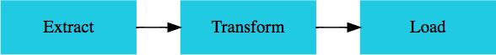

ETL (Extract, Transform, and Load): Retrieve data, process and store it Data can be from multiple sources

Recommended for simple processing:
Basic data cleaning tasks, de-duplicating data, formatting data
Example: Ensure data privacy and compliance
Removing sensitive data before it reaches analytical data models

Can run each of the phases in parallel
While extract is going on, you can transform data which is already loaded

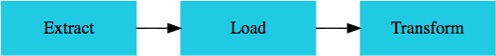

ELT (Extract, Load, and Transform): Data is stored before it is transformed Uses an iterative approach (multiple steps) to process data in target system Needs a powerful target datastore:
Target datastore should be able to perform transformations

Advantage: Does NOT use a separate transformation engine
Typical target data stores: Hadoop cluster (using Hive or Spark), Azure Synapse Analytics
Enables use of massively parallel processing (MPP) capabilities of data stores

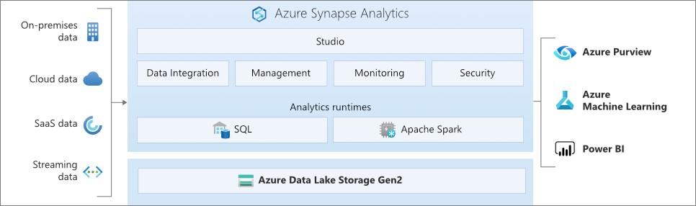

(https://docs.microsok.com)
Develop end-to-end analytics solutions
Data integration + Enterprise data warehouse + Data analytics
SQL technologies + Spark technologies + Pipelines
Full integration with Power BI, Cosmos DB, and Azure ML

In a workspace, create pipelines for:

Data Ingestion:
Ingest data from 90+ data sources (Cosmos DB,AWS, GCP..)
Stream data into SQL tables
Data Storage: Datasets - Azure Storage, Azure Data Lake Storage
Formats: Parquet, CSV, JSON ..
Data Processing: Mix & match SQL and Spark
SQL pool: SQL Database supporting distributed T-SQL queries
Two consumption models: dedicated and serverless
Recommended for complex reporting & data ingestion using Polybase SQL Pool can be paused to reduce compute costs
Apache Spark pools: Run Spark based workloads
1: Create Spark data analysis notebooks OR
2: Run batch Spark jobs (jar files) Recommended for data preparation and ML


(https://docs.microsok.com)


Fully managed serverless service to build complex data pipelines:
Extract-transform-load (ETL), extract-load-transform (ELT) and data integration
90 built-in connectors
Ingest data from:
Big Data sources like Amazon Redshift, Google BigQuery
Enterprise data warehouses like Oracle Exadata, Teradata All Azure data services
Build data flows to transform data
Integrate with services like Azure HDInsight, Azure Databricks, Azure Synapse Analytics for data processing
Move SQL Server Integration Services (SSIS) packages to cloud

CI/CD support with Azure Devops

Create a Data Lake Storage Account Gen2 Create a SQL Server Database

Task: Extract data from SQL Server to CSV file

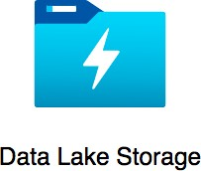
Blob storage + Hierarchical directory structure Configure permissions(RBAC) at file and directory level

Fully compatible with Hadoop Distributed File System (HDFS)
Apache Hadoop workloads can directly access data in Azure Data Lake Storage

Three main elements:
Data Lake Store: Azure Data Factory, Azure Databricks, Azure HDInsight, Azure Data Lake Analytics, and Azure Stream Analytics can read directly
Data Lake Analytics: Run analytics jobs using U-SQL
HDInsight: Run Hadoop jobs


Pipeline: Logical group of activities that can be scheduled
You can chain activities in a pipeline
You can run activities sequentially or in parallel A pipeline can execute other pipelines

Activity: Represents a step in a pipeline (an action to be performed)
Copy Activity: Copy data from one store to another store
Example: Copy CSV from Blob Storage to a Table in SQL Database
Three types of activities: Data movement, Data transformation, Control activities

Data Flow: Create and manage data transformation logic
Build reusable library of data transformation routines
Executes logic on a Spark cluster:
You don't need to manage the cluster (it is spun up and down automatically as needed)

Control flow: Orchestrate pipeline activity based on output of another pipeline activity


Linked Service: Used to connect to an external source
Connect to different sources like Azure Storage Blob, SQL Databases etc

Dataset: Representation of data structures within data stores
Integration Runtime: Compute infrastructure used by Azure Data Factory allowing you to perform

Triggers: Trigger pipeline at a specific times


Power BI: Unify data and create BI reports & dashboards
Integrates with all Azure analytics services
Azure Synapse Analytics to Azure Data Lake Storage

Power BI Components
Power BI Service: Online SaaS (Software as a Service) service
Power BI online - app.powerbi.com
Create/share reports and dashboards
Power BI Desktop: Windows desktop application to create and share reports
More data sources, Complex modeling and transformations
Power BI Report Builder: Standalone tool to author paginated reports
Power BI Mobile Apps: Apps for Windows, iOS, and Android devices

Typical Power BI Workflow:
1: Create a report with Power BI Service/Desktop (or paginated report with Power BI Report Builder)
2: Share it to the Power BI service
3: View and interact with report (and create dashboards) using Power BI service
Reports can also be accessed from Power BI mobile


Workspace: Container for dashboards, reports, workbooks & datasets
Dataset: Collection of data
Can be a file(Excel, CSV etc) or a database
Azure SQL Database, Azure Synapse Analytics, Azure HDInsight, ..
Each dataset can be used in multiple reports
Report: One or more pages of visualizations
Highly interactive and highly customizable
All data for a report comes from a single dataset A report can be used in multiple dashboards
Paginated Reports: Create pixel perfect multi page reports for printing & archiving (PDF/Word)
Create in "Power BI Report Builder" and publish to use in Power BI service
Dashboard: Single page - visualizations from one or more reports
Technically a canvas with multiple tiles
Monitor the most important information at one glance and dig deeper, if needed
You can select a tile and go to a report page to dig deeper

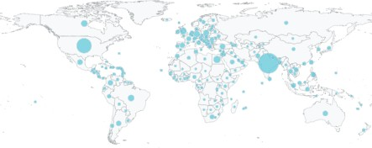
Bar and column charts: Most basic of charts

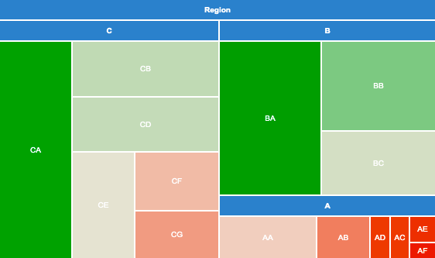
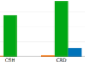
Line Charts: Emphasize shape of a series of values over time Pie Charts: Displays division of total into different categories Matrix: Summarize data in a tabular structure
Treemap: Charts of colored rectangles

Scatter: Shows relationship between two numerical values
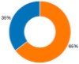
Bubble chart: Replace data points with bubbles
Bubble size represents a 3rd dimension
Filled map: Show on a Map
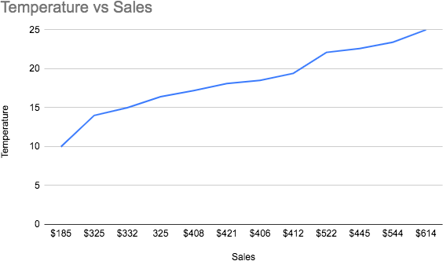
Cards: Single number
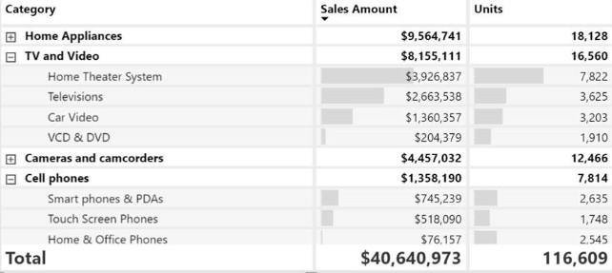
Link: Reference for all visualization options in Power BI


Data Ingestion: Capture raw data
Azure Data Factory: data ingestion and transformation service
Ingest streaming and batch data
Data from on-premises and cloud
PolyBase: Run T-SQL queries on external data sources
PolyBase makes external data sources appear like tables
SQL Server Integration Services (SSIS): on-premises tool data integration and data transformation solution that is part of Microsoft SQL Server
Run existing SSIS packages as part of Azure Data Factory pipeline
Spark: Ingest streaming data
IOT Hub: Managed message hub for IoT devices
Event Hub: Big data streaming platform and event ingestion service


Data Processing and Storage:
Azure Data Lake Storage Gen2: Data lake storage
Azure Synapse Analytics: Data processing can be done using:
1: T-SQL - Query using SQL from databases, files, and Azure Data Lake storage
2: Spark - Write and run Spark jobs using C#, Scala, Python, SQL etc
Azure Databricks: Process data from Azure Blob storage, Azure Data Lake Store, Hadoop storage, flat files, databases, and data warehouses
Handle streaming data
Azure HDInsight: Storage - Azure Data Lake storage
Analyze data using Hadoop Map/Reduce, Apache Spark, Apache Hive (SQL)
Azure Data Factory: Build pipelines and data-driven workflows
Ingest data from relational and non-relational systems


Data Querying: Run queries to analyze data
Recommended Services: Azure Synapse Analytics, Hive (SQL)
Data Visualization: Create dashboards, charts and reports
Recommended Services: Power BI

Decide Data Analysis Category: You have generated a report showing current status vs planned
Descriptive analytics

Decide Data Analysis Category: Why did sales increase last month? Diagnostic analytics Decide Data Analysis Category: Semantic Analysis of Text (Analyze reviews) Cognitive analytics You want to move your Hadoop workloads to the cloud Azure HDInsight
Stream or Batch: Processing aher you received 10K records Batch

You want to move SQL Server Integration Services (SSIS) packages to cloud Use Azure Data
Factory

Categorize activity: Copy data from one store to another store Data movement

Categorize activity: Orchestrate pipeline activity based on output of another pipeline activity
Control flow

You want to connect to an external source from Data Factory Linked Service

Compute infrastructure used by Azure Data Factory Integration Runtime

Standalone tool to author paginated reports Power BI Report Builder

What is Online SaaS Power BI called? Power BI Service

Which of these represents "One or more pages of visualizations in Power BI"? Report

Which of these represents "Single page visualizations from one or more reports"? Dashboard

Other Important
Concepts

Azure

Tool Description

Azure Data Studio Cross-platform (Windows, Mac, linux) db tool with Intellisense, code snippets and source control
Run SQL queries. Save results in different formats - text, JSON, Excel Supports SQL Server, Azure SQL Database, Azure Synapse Analytics..
Notebooks: Create and share documents with text, images and SQL query results Support to create and restore backup from SQL Database

SQL Server
Management Studio (SSMS)

SQL Server Data Tools (SSDT)
Graphical tool for managing SQL Server and Azure Databases Query, design, and manage your databases and data warehouses Supports configuration, management and administration tasks Suitable for SQL Server, SQL Database, Azure Synapse Analytics
Build SQL Server and Azure SQL relational databases, Analysis Services (AS) data models, Integration Services (IS) packages, and Reporting Services (RS) reports

sqlcmd Run SQL scripts and procedures from command line
Supports SQL Server, Azure SQL Database, Azure SQL MI, Azure Synapse Analytics

Role Description

Database Administrator

Data Engineers
Role: Install, upgrade, control (authorization, availability, durability, performance
optimization, backups, disaster recovery, compliance with licensing) of data servers
Tools: Azure Data Studio, SQL Server Management Studio (SSMS)
Responsible for data architecture, data acquisition, data ingestion, data processing
(transformation, cleansing and pipelines) and data storage (design, build and test) for analytical workloads
Responsible for build, test, monitoring, performance optimization of data pipelines Responsible for improving data reliability, efficiency, and quality
Tools: Azure Data Studio, Azure HDInsight, Azure Databricks, Azure Data Factory, Azure Cosmos DB, Azure Storage ...
Programming Languages - HiveQL, R, or Python

Data Analyst Responsible for getting intelligence from data through integration of data(from multiple sources), dashboards, reports, visualizations (charts, graphs, ..) and pattern identification (from huge volumes of data)
Tools: Microsoft Excel, Power BI...


Estimate the costs for Azure services

Example Services that you can estimate costs for:
Virtual Machines
Storage Accounts Azure SQL Database Azure Cosmos DB
...

Ideal place to explore and learn important factors about different Azure services

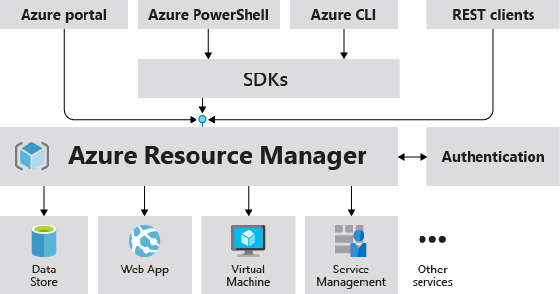
(https://docs.microsok.com/)

Deployment and management service for Azure
All actions to any resource in Azure go through ARM
Irrespective of where you are performing it from
Azure portal OR Powershell OR CLI or ARM template or ...


Lets consider an example:
I would want to create an Azure SQL Database
I would want to create an Azure Data Lake Storage Gen2 I would want to create an Azure Data Factory Workspace

AND I would want to create 4 environments
Dev, QA, Stage and Production!
Azure Resource Manager (ARM) templates can help you do all these with a simple (actually NOT so simple) script!

Tool Details

Azure Portal Web-based user interface. Great to get started BUT NO automation possible.
Runs in all modern desktop and tablet browsers

Azure PowerShell Execute cmdlets (sequence of commands) and create scripts (PowerShell script) Recommended for teams familiar with Windows administration
Cross-platform (Windows, Linux, and macOS)

Azure CLI Similar to Azure PowerShell BUT uses a different syntax (Bash Scripts)
Recommended for teams familiar with Linux administration (and Bash Scripts) Cross-platform (Windows, Linux, and macOS)

Azure Cloud Shell Free Browser based interactive shell (Access from Azure Portal)
Common Azure tools pre-installed and configured to use with your account Supports both PowerShell and CLI (bash)
Runs in all modern desktop and tablet browsers

Hierarchy: Management Group(s) > Subscription (s) > Resource Group (s) > Resources
Resources: VMs, Storage, Databases
Resource groups: Organize resources by grouping them into Resource groups
Subscriptions: Manage costs for resources provisioned for different teams or different projects or different business units
Management groups: Centralized management for access, policy, and compliance across multiple subscriptions

Remember:
No hierarchy in resource groups BUT management groups can have a hierarchy

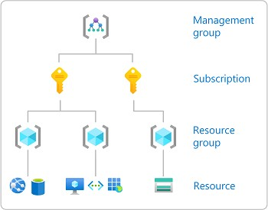
(https://docs.microsok.com/)

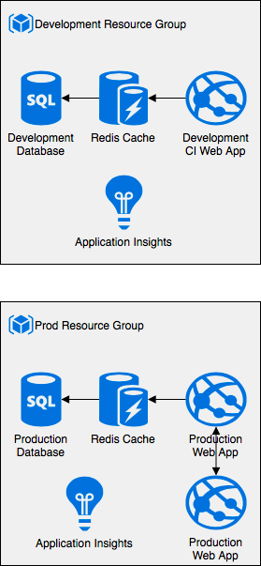
Resource Group: Logical container for resources
Associated with a single subscription
Can have multiple resources
(REMEMBER) A resource can be associated with one and only one resource group
Can have resources from multiple regions Deleting it deletes all resources under it

Tags assigned to resource group are not automatically applied to resources
HOWEVER, Permissions/Roles assigned to user at the resource group level
are inherited by all resources in the group

Resource Groups (like Management Groups) are free


You need a Subscription to create resources in Azure
Subscription links Azure Account to its resources
An Azure Account can have multiple subscriptions and multiple account administrators

When do you create a new subscription?
I want to manage different access-management policies for different environments:
Create different subscriptions for different environments
Manage distinct Azure subscription policies for each environment
I want to manage costs across different departments of an organization:
Create different subscriptions for different departments
Create separate billing reports and invoices for each subscription (or department) and manage costs
I'm exceeding the limits available per subscription
Example: VMs per subscription - 25,000 per region

Allows you to manage access, policies, and compliance across multiple subscriptions
Group subscriptions into Management Groups
All subscriptions & resources under a Management Group inherit all constraints applied to it

(REMEMBER) You can create a hierarchy of management groups
(REMEMBER) All subscriptions in a management group should be associated with the same Azure AD tenant


(https://docs.microsok.com/)

Quick Review

Service Description

Azure Disk storage Store disks attached to VMs.

Azure Blob storage Store unstructured data - video files, database archives etc.

Azure File storage Create file shares or file servers in the cloud

Azure Queue storage
Azure Table storage
Decouple applications using a queue (asynchronous communication)

Store structure data using NoSQL approach (NON-relational). Schemaless. Key/attribute store.

Service Description

SQL Server on Azure Virtual Machines
Provides full administrative control over the SQL Server instance and underlying OS for migration to Azure

Azure SQL Database Fully Managed Service for Microsoft SQL Server.
Recommended for cloud-born applications

Azure SQL managed instance

Azure Database for MySQL
Azure Database for PostgreSQL
Full (Near 100%) SQL Server access and feature compatibility Recommended for migrating on-premise SQL Server databases
Azure SQL managed instance ONLY features: Cross-database queries, Database Mail Support, SQL Server Agent etc.
Fully managed MySQL database Fully managed PostgreSQL database

Azure Databases - Quick Review - 2
Service Description

Azure Cosmos DB NoSQL database. Globally distributed.
Core(SQL), MongoDB, Table, Gremlin and Cassandra APIs

Azure Cache for Redis Managed service for Redis (high-throughput, low-latency data caching)

Azure Database Migration Service Migrate databases to the cloud

Azure Analytics
Services -

Quick
Review

Service Description

Azure Data Lake Storage Data lake built on Azure Blob Storage

Azure Databricks Managed Apache Spark

Azure HDInsight Managed Apache Hadoop

Azure Synapse Analytics End-to-end analytics solutions
Data integration + Enterprise data warehouse + Data analytics

Azure Data Factory Data Integration. Fully managed serverless service to build complex data pipelines.

Power BI Create visualization around data - reports & dashboards

Event Hubs Receive telemetry from millions of devices

Get Ready


Certification Home Page
https://docs.microsok.com/en-gb/learn/certifications/exams/dp-900

Different Types of Multiple Choice Questions
Type 1 : Single Answer - 2/3/4 options and 1 right answer
Type 2 : Multiple Answer - 5 options and 2 right answers
No penalty for wrong answers
Feel free to guess if you do not know the answer
40-60 questions and 65 minutes

Result immediately shown after exam completion Email with detailed scores (a couple of days later)


Read the entire question
Identify the key parts of the question

Read all answers at least once
If you do NOT know the answer, eliminate wrong answers first
Mark questions for future consideration and review them before final submission

You are all set!


You have a lot of patience! Congratulations
You have put your best foot forward to get Microsoft Certification - DP-900: Microsoft Azure Data Fundamentals
Make sure you prepare well and
Good Luck!


Recommend the course to your friends!
Do not forget to review!

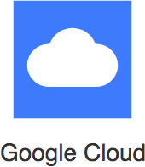
Your Success = My Success
Share your success story with me on LinkedIn (Ranga Karanam)
Share your success story and lessons learnt in Q&A with other learners!



https://github.com/in28minutes/roadmaps

Simplified Roadmaps to Learn:
AWS
Azure
Google Cloud DevOps
Full Stack Development

